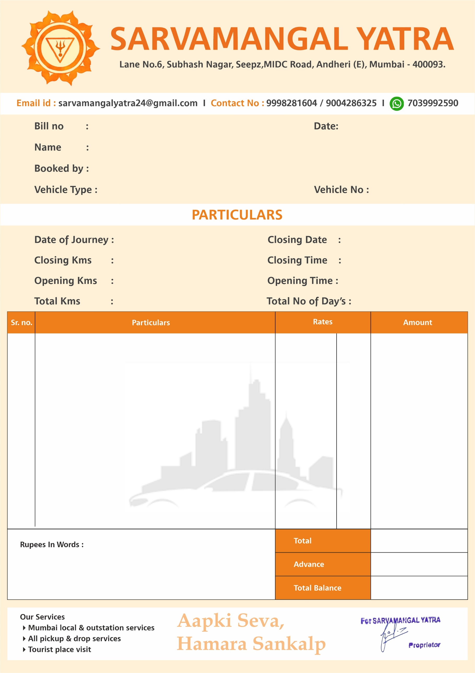

Sedan

MH03ES578Y

Krishna

09/08/25

109

Vijay Prakash Rai

1.

Local Charge:

4 Hr: 40KM

22

1

12:30 PM

2984

3006

4:20 PM

29/08/25

29/08/25

1200

1200

Twelve Hundred Rupees Only

1200Rs